**Step 1:**

In the Bucket name list, choose the name of the bucket that you want

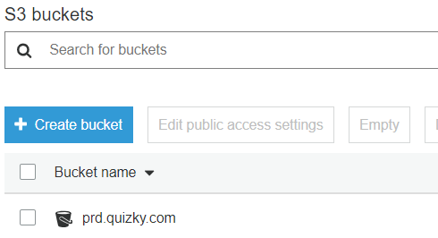

**Step 2:**

To see a list of the versions of the objects in the bucket, select Show. You'll be able to see the delete markers for deleted objects.

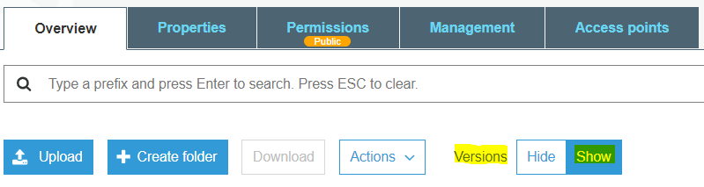

**Step 3:**

To undelete an object, you must delete the delete marker. Select the check box next to the delete marker of the object to recover, and then choose to delete from the Actions menu.

